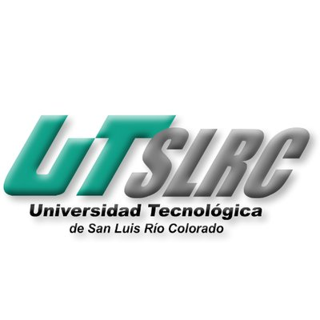

**UNIVERSIADAD TECNOLÓGICA DE**

**SAN LUIS RIO COLORADO**

**JUSTICE PRINCIPLES**

**MTRA. YESENIA CORAL FLORES FLORES**

**AUTOR: VICTOR MANUEL GALVAN COVARRUBIAS**

San Luis Rio Colorado, Sonora Marzo, 2020

The NOM-161

It is a law in Mexico that promotes the management or and establishes the criteria of the special management trash. This law promotes sustainability not only because it seeks adequate management of waste that has a high potential for pollution to the environment, but also because it contemplates the different routes of action.

According to the document it also contains some of the mentioned justice principles. For example, the integration and participation of people in the process of this law making sure of the fulfillment of this.

Environmental policy in China

The Ministry is tasked with protecting China's air, water, and land from pollution. It is empowered and required by law to implement environmental policies and enforce environmental laws and regulations. Complementing its regulatory role, it funds and organizes research and development. There are 20 offices and departments under this regulation.

According to the justice principles this policy makes sure of the security of the natural resources and human health. Without this policy the conditions in china could be even worse than the ones right now in the country.

<https://www.expoknews.com/3-leyes-mexicanas-que-promueven-el-desarrollo-sostenible/>

<https://en.wikipedia.org/wiki/Environmental_policy_in_China#Policy_jurisdiction>